WESTWOOD UNITED METHODIST CHURCH

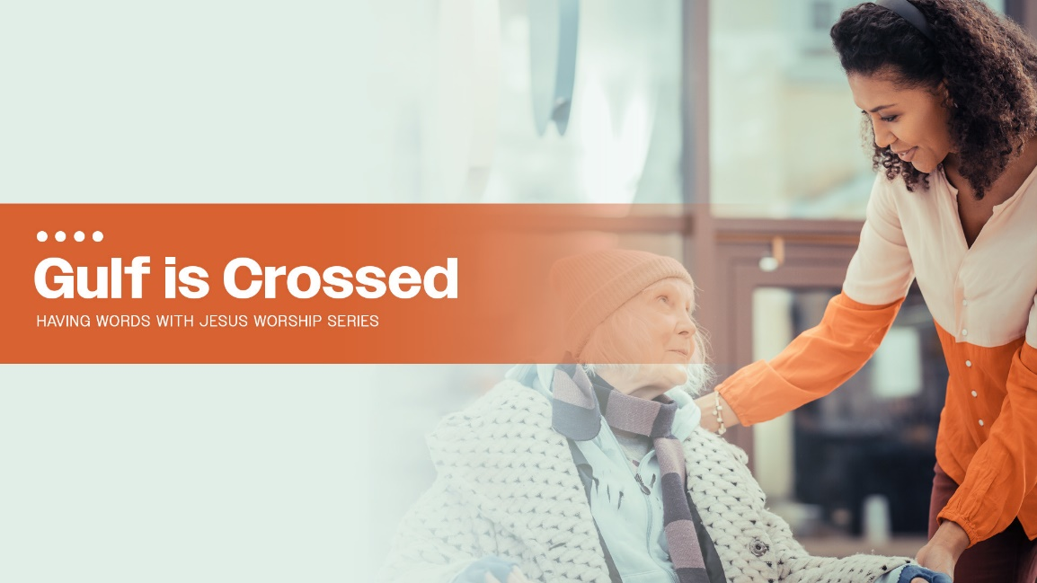

September 25, 2022 10:00 am

sixteenth sunday after pentecost

PRELUDE  "Adagio," Alexandre Guilmant

WELCOME

CALL TO WORSHIP

Come and worship!

**We will praise the One between, within, and over.**

Trust in the One who co-creates the was, the now, and the will-be.

**Our hope is in the One who creates expansive love calling us to do the same.**

Follow the One who never breaks covenant.

**We follow the One whose extravagant love calls us to co-create justice for the oppressed, feed the hungry, unlock prisons, and welcome strangers, orphans, and widows.**

Praise the One whose justice is grace-full and inclusive.

**We praise the Spirit that spans the ages. Amen!**

*Written by Tim Graves and posted on LiturgyBits.* [*https://liturgybits.wordpress.com*](https://liturgybits.wordpress.com)*.*

SONG

“The Voice of God Is Calling”

UMH 436

OPENING PRAYER

**God, regret is such a frightening word. It assumes that we are broken, imperfect and will fail. It places so much pressure on us to perform and do the right thing. We really don't want to live with regrets, yet the truth is, we will. No matter how much we do right, there will be moments where we will choose the lesser thing, turn down the wrong road, or follow our hearts instead of yours. But, this we know -- your grace is greater. It is greater than our wrong choices, our failings, our mishaps. You never look upon us with regret. You see us as we are and love us in it all. Thank you so much. We are overwhelmed. Amen.**

PEACE

The peace of the risen Christ is with you. **And also with you.** Let us wave to one another as a sign of passing that peace to others.

**SCRIPTURE READINGS**

**Psalm 91:1-6, 14-16 (Read responsively)**

**Luke 16:19-31**

This is a Word of God for the people of God.

**Thanks be to God!**

MUSICAL PROCLAMATION

*"Sanctuary,"*

*J. Thompson/R. Scruggs, arr. L. Larson*

**SERMON**

**"Gulf is Crossed”**

Pastor Wayne



**OFFERTORY PRAYER**

**God of justice and mercy, we come to worship you this day as ones who, on the great balance scale of your creation, are more like the rich man in the Gospel story than we are Lazarus. The parable Jesus tells reminds us that the chasm between rich and poor is hard to cross in the life to come, but not so for us this day, as we strive to see God’s kingdom at work in our world. As we offer gifts today, may we do so striving to be those blessed to be a blessing. In Christ’s holy name, we pray. Amen.**

CALL TO PRAYER “Cares Chorus”

FWS 2215

PRAYERS OF THE PEOPLE

THE LORD’S PRAYER

**Our Father who art in heaven, hallowed be thy name, thy kingdom**

**come, thy will be done on earth as it is in heaven. Give us this day our daily bread; and forgive us our trespasses as we forgive those who trespass against us. And lead us not into temptation, but deliver us from evil, for thine is the kingdom, and the power and the glory forever. Amen.**

**SONG**

“Blessed Assurance”

FWS 2215

BENEDICTION

POSTLUDE   Postlude on "All the Way," Chas. Callahan

ANNOUNCEMENTS