WESTWOOD UNITED METHODIST CHURCH

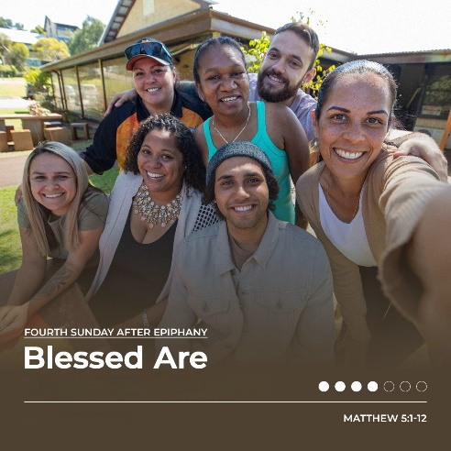

January 29, 2023 10:00 am

Fourth sunday after the epiphany

PRELUDE "But the Lord is Mindful," Felix Mendelssohn

WELCOME

CALL TO WORSHIP

Happy are we

**when our treasures cannot be quantified.**

Happy are we

**when our knowledge is tempered by mystery.**

Happy are we

**when our pain is held in the balm of love.**

Happy are we

**when our delight comes from beyond ourselves.**

Written by Katherine Hawker (2006) and posted on Liturgy Outside. Reposted: <https://re-worship.blogspot.com/2013/08/call-to-worship-beatitudes.html>.

SONG

"For All the Saints"

FWS 2283

OPENING PRAYER

**Loving God, we come this morning seeking to abide in your presence. Open our minds to your spirit of wisdom, that we may know how to live as your people. Open our hearts to your spirit of truth, that we may love all your people with a love that speaks of justice, kindness, and radical grace. May this time of worship be authentic and pleasing to you. Amen.**

PEACE

The peace of the risen Christ is with you. **And also with you.** Let us wave to one another as a sign of passing that peace to others.

**SCRIPTURE READINGS**

**Psalm 15 (Read responsively)**

**Matthew 5:1-12**

This is a Word of God for the people of God.

**Thanks be to God!**

MUSICAL PROCLAMATION *"In This Very Room,"*

*Ron and Carol Harris*

**SERMON**

**“Blessed Are”**

Pastor Wayne



**OFFERTORY PRAYER**

**God of all blessings, your beloved son teaches all we need to know to claim the life you’ve hoped for us. In spite of that, we live like the rest of the world that is eager to accumulate and reluctant to give, showering adoration on the rich and powerful and pushing the poor and powerless. And we bring to you our gifts, which are the result of your blessings, help us to remember who Jesus called truly blessed! We pray in the name of our teacher and savior. Amen.**

CALL TO PRAYER “Sweet, Sweet Spirit"

UMH 334

PRAYERS OF THE PEOPLE

THE LORD’S PRAYER

**Our Father who art in heaven, hallowed be thy name, thy kingdom**

**come, thy will be done on earth as it is in heaven. Give us this day our daily bread; and forgive us our trespasses as we forgive those who trespass against us. And lead us not into temptation, but deliver us from evil, for thine is the kingdom, and the power and the glory forever. Amen.**

**SONG**

“Hymn of Promise”

UMH 707

BENEDICTION

POSTLUDE  "Ellecombe," Albert L. Travis

ANNOUNCEMENTS