WESTWOOD UNITED METHODIST CHURCH

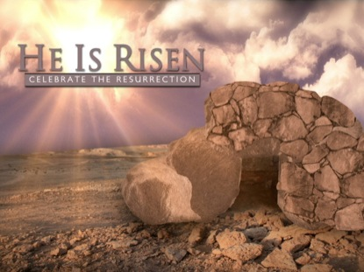

April 12, 2020 10:00 AM

easter sunday

PRELUDE "Come, Ye Faithful" R. S. Thatcher

WELCOME & ANNOUNCEMENTS

GATHERING HYMN “Christ the Lord Is Risen Today” UMH 302

REFLECTIONS ON EASTER VIDEO

OPENING
Easter is not just a day. It is a whole season of time when we remember that Jesus’ Spirit lives on in each one of us. In the Bible, the early church was described in this way:

“Day by day, as they spent much time together in the temple, they broke bread at home and ate their food with glad and generous hearts, praising God and having the goodwill of all the people.” (Acts 2: 46-47a) So over the next few weeks, we are following our ancestor’s traditions. We are creating a “temple” of worship in our hearts whether we can be physically together or not. By sharing in words and music and breathing and eating and moving together, we will stay connected. The earliest Christians worshiped in their homes before they had churches, and so will we, until we can meet again in our sanctuaries. Because at the “heart of the matter,” we are connected through the Spirit that makes us one in love.

CENTERING PRAYER

MUSIC MINISTRY "Risen Indeed!" Allen Pote

CALL TO PRAYER “Let It Breathe On Me” UMH 503

PRAYERS OF THE PEOPLE

GIVING OUR GIFTS We can give online at our website:

www.umc-westwood.org

or we can mail our gifts in to the church office:

105 Fairview Ave. Westwood, NJ 07675
OFFERTORY PRAYER
O God, you unconditionally share your only son with all who believe in your name. On this holy day, receive our offerings as an affirmation of our commitment to be your faithful disciples. Strengthen our ability to be gifted stewards of your created world. We pray in the name of the Resurrected One, Jesus Christ, the Messiah. Amen.

FIRST SCRIPTURE LESSON
Reader: One of the scriptures for this year’s Easter selections is from the book of Jeremiah. The people of Jeremiah’s time were going through trauma. Jeremiah was frustrated with their behavior for many chapters but ultimately his tone changes and he prophesies God’s promise that they will be built back up from the devastation they have endured. They will again feel joy and they will begin to plan for the future again, planting vineyards on the hills even in the midst of exile and pain. Here these words of promise:
Jeremiah 31:1-6

PRAYER
God of new dawns, new awakenings, new life, we hear your voice this morning saying, “I have loved you, my people, with an everlasting love. With unfailing love I have drawn you to myself.” On this Easter day, you tell us we will be rebuilt and made new. In gratitude we hear you, Living God, and we believe you. And so we will celebrate the gift of new life in Christ, even in the midst of fear. You give us eyes to see through tears, songs to sing with throats tight with emotion. We know you help the weary rise up out of the ashes. Give us the courage to be your light and hope in this world today. Amen.

HYMN “Love Divine, All Loves Excelling” UMH 384

GOSPEL LESSON
Reader: In the account of the resurrection in the Gospel of Matthew, after the stone is rolled away from the tomb, the angel sits on the stone and gives the women this message, “Don’t be afraid.” Throughout the Season of Easter, we invite you to use a “worry stone,” which is a stone you carry about with you to rub when you are feeling anxious or worried. We encourage you to find a stone and paint or draw a heart on it. It will remind you of this angel’s message which Jesus then repeats, “Do not be afraid.” Hear this wonderful message now from Matthew 28:1-10:

The word of God for the people of God! Thanks be to God!

TODAY’S MESSAGE “Fear Not” Pastor Wayne

THE GREAT THANKSGIVING

THE LORD’S PRAYER
Our Father who art in heaven, hallowed be thy name, thy kingdom come, thy will be done on earth as it is in heaven. Give us this day our daily bread; and forgive us our trespasses as we forgive those who trespass against us. And lead us not into temptation, but deliver us from evil, for thine is the kingdom, and the power and the glory forever. Amen.

AFFIRMATION OF FAITH UMH 883

CLOSING HYMN “Up from the Grave He Arose” UMH 322

BENEDICTION

POSTLUDE "Ballade" Op. 118, No. 3 Johannes Brahms

