WESTWOOD UNITED METHODIST CHURCH

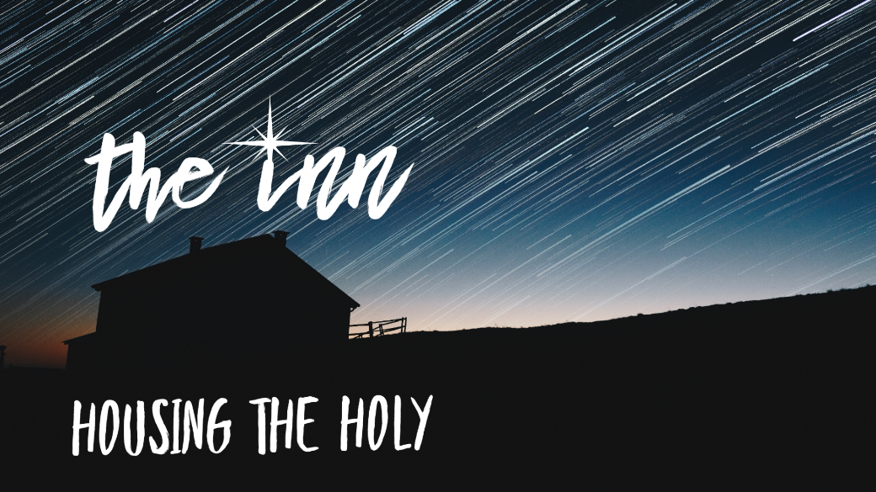

December 24, 2021 10:00 AM

Christmas eve

PRELUDE  "In Dulci Jubilo,"

Gordon Young

WELCOME

OPENING OURSELVES TO WORSHIP

LIGHTING THE ADVENT CANDLE

Tonight we light all the candles of the advent wreath. The first Candle is called HOPE and it is a reminder that God’s promises are true.

**The second Candle is called PEACE, God’s gentle loving peace for our lives.**

The third Candle is called JOY, because of God’s absolute presence in our lives.

**The fourth Candle is called LOVE, because of God’s great love for us.**

Now the time is near! The One who will save us, brings God’s light into our world. We light this Christ Candle in celebration of God’s most precious gift to us - our Savior Jesus Christ.

*{Light all of the Candles}*

CAROL

“Joy to the World”

UMH 246

THE STORY OF CHRISTMAS

**The Nativity**

Carol: *Away in a Manger* (verses 1, 2)

**The Holy Family (Luke 2: 1-7)**

Carol: *What Child is This?* (verse 1)

**The Angels (Luke 2: 8-14)**

Carol: *Hark! the Herald Angels Sing* (verse 1)

**The Shepherds (Luke 2: 15-20)**

Carol: *The First Noel* (verse 1)

**The Christmas Star (Matthew 2: 1 - 6)**

Carol: *The First Noel* (verse 4)

**The Wise Men (Matthew 2: 7 - 11)**

Carol: *We Three Kings* (verse 1)

CAROL “Go Tell It On the Mountain”



OFFERTORY PRAYER

**Holy God, as we gather this evening, all our attention is focused on a baby, lying in a makeshift bed in an “it-will-have-to-do” stable. It’s not lost on us that you sent your Son, our Savior, into the world among the poorest of the poor and told us: “This will be a sign to you.” As we present gifts to you, we pray that they might reach those in the greatest need, that they might lift those in the deepest despair, and that they might bring peace and compassion to those who find themselves amidst conflict. We pray this in the name of that Holy Child, Jesus the Christ, our Savior and Redeemer! Amen.**

SONG “O Come, O Come Emmanuel”

Arr. Brenda E. Austin, Choir and Hand Bells

A CHRISTMAS COMMUNION

THE LORD’S PRAYER

**Our Father who art in heaven, hallowed be thy name, thy kingdom come, thy will be done on earth as it is in heaven. Give us this day our daily bread; and forgive us our trespasses as we forgive those who trespass against us. And lead us not into temptation, but deliver us from evil, for thine is the kingdom, and the power and the glory forever. Amen.**

INTRODUCTION TO “Silent Night”

*For those joining us on ZOOM, please lift up your lit candle as we prepare to sing “Silent Night” together. Those who are in the Sanctuary, as the light comes to you please dip your unlit candle into the flame and then hold your lit candle upright offering it to your neighbor. We will be singing* ***"Silent Night"*** *while the light is being distribut­ed. Please extinguish the candles after the benediction.}*

CAROL “Silent Night” UMH 239

BENEDICTION