WESTWOOD UNITED METHODIST CHURCH

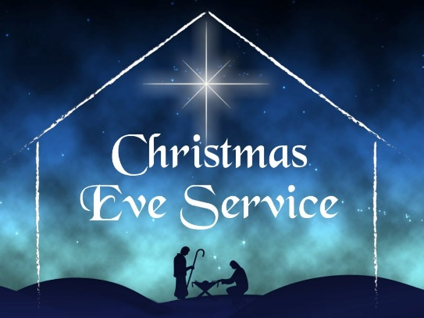

December 24, 2022 10:00 am

Christmas eve

PRELUDE Choral Prelude on "Cradle Song," Gordon Young

WELCOME

LIGHTING OF THE ADVENT WREATH

Tonight, we sit among the reflection of the lights of Christmas. You have likely had some Christmas lights up at home for a little while, and you’ve seen lights decorating houses and stores in our neighborhoods and cities. Shining lights this time of year seem to help soften our focus a bit, allowing us to see the ordinary places and people lit up in the reflections. Even our houses can feel special with the trees’ lights illuminating the room in a magical way. I hope you’ve had a few moments to stop and notice and take it in. Times of quiet contemplation are not just good for the soul, they are good for our whole being, and our being with each other.

Please repeat after me:

We pray for Hope this night.

**We pray for Hope this night.**

***[light the first purple candle]***

We pray for Love this night.

**We pray for Love this night.**

***[light the second purple candle]***

We pray for Joy this night.

**We pray for Joy this night.**

***[light the pink candle]***

We pray for Peace this night.

**We pray for Peace this night.**

***[light the third purple candle]***

We open to see the Sacred reflected in all things.

**We open to see the Sacred reflected in all things.**

We open to see our deepest selves

**We open to see our deepest selves**

As a gift of holy presence.

**as a gift of holy presence.**

This is the gift of the Christ Mystery,

**This is the gift of the Christ Mystery,**

lighting the way to peace.

**lighting the way to peace.**

***[light the white Christ candle]***

CAROL

“O Come All Ye Faithful”

UMH 234

OPENING PRAYER

**Living God, Christ Mystery, Holy Spirit, we give you thanks for this holy sensing of your presence. As we take in the light you offer, may we be a reflection of that light, expanding the sacred being of this place into the sacred being of all things. Amen.**

CAROL “Joy to the World” UMH 246

THE STORY OF CHRISTMAS

The Nativity

Carol: *Away in a Manger* (verses 1, 2)

The Holy Family (Luke 2: 1-7)

Carol: *What Child is This?* (verse 1)

The Angels (Luke 2: 8-14)

Carol: *Hark! the Herald Angels Sing* (verse 1)

The Shepherds (Luke 2: 15-20)

Carol: *The First Noel* (verse 1)

The Christmas Star (Matthew 2: 1 - 6)

Carol: *The First Noel* (verse 4)

The Wise Men (Matthew 2: 7 - 11)

Carol: *We Three Kings* (verse 1)

CAROL “Go Tell It On the Mountain”



**OFFERTORY PRAYER**

**God of the stars and the angels’ songs, as we gather this evening, all our attention is focused on a baby, lying in a makeshift bed in an “it-will-have-to-do” stable. It’s not lost on us that you sent your Son, our Savior, into the world among the poorest of the poor and told us: “This will be a sign to you.” As we present gifts to you, we pray that they might reach those in the greatest need, that they might lift those in the deepest despair, and that they might bring peace and compassion to those who find themselves amidst conflict. We pray this in the name of that Holy Child, Jesus the Christ, our Savior and Redeemer! Amen.**

SONG “Carol of the Bells” Hand Bells

A CHRISTMAS COMMUNION

**LORD’S PRAYER**

**Our Father who art in heaven, hallowed be thy name, thy kingdom come, thy will be done on earth as it is in heaven. Give us this day our daily bread; and forgive us our trespasses as we forgive those who trespass against us. And lead us not into temptation, but deliver us from evil, for thine is the kingdom, and the power and the glory forever. Amen.**

**INTRODUCTION TO “Silent Night”**

***For those joining us on ZOOM, please lift up your lit candle as we prepare to sing “Silent Night” together. Those who are in the Sanctuary, as the light comes to you please dip your unlit candle into the flame and then hold your lit candle upright offering it to your neighbor. We will be singing "Silent Night" while the light is being distribut­ed. Please extinguish the candles after the benediction.}***

**CAROL “Silent Night” UMH 239**

**BENEDICTION**

**POSTLUDE**