WESTWOOD UNITED METHODIST CHURCH

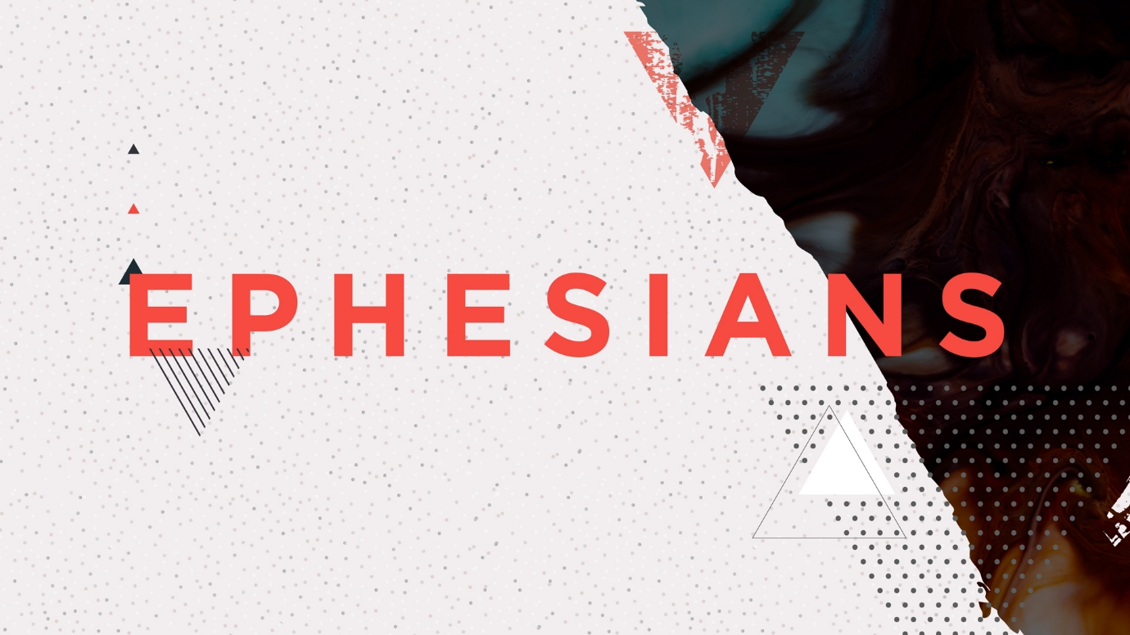

July 25, 2021 10:00 AM

NINTH sunday after pentecost

PRELUDE "Bist du Bei Mir," H.S. Bach

WELCOME

CENTERING MOMENT

GREETING

Fools say in their hearts, “There is no God.”

**Too often we have been fools in word or deed.**

Still, the Lord looks from heaven for those who seek God.

**May we be found among the company of the righteous!**

Deliver us from evil, O God. Restore your people’s fortunes.

**Lord, only in you can we find refuge. Amen.**

**SONG**

“O Spirit of the Living God” UMH 539

OPENING PRAYER

**Holy One, we bow our hearts before you this day. Strengthen us in our innermost being**

**and dwell in our hearts through faith. May we be rooted and grounded in Christ, whose love is beyond all knowledge. Help us comprehend even the smallest part of the beautiful mystery of your grace. Grant that we may experience the fullness of your presence with us. Amen.**

PEACE

The peace of the risen Christ is with you.

**And also with you.**

Let us wave to one another as a sign of passing that peace to others.

**SCRIPTURE READINGS**

Psalm 14 (Read Responsively from UMH 746)

Ephesians 3:14-21

This is a Word of God for the people of God. **Thanks be to God!**

MUSICAL PROCLAMATION

*"There's a Sweet, Sweet Spirit in This Place,"*

*Doris Akers*

**SERMON**

“Rooted and Grounded in Love”

Pastor Wayne



OFFERTORY PRAYER

**Mighty and all-knowing God who sees us as we are and as we might be: What offering can we give that will bring you joy? We have brought gifts this morning that you might dedicate them to the work of caring and compassion in our neighborhoods, in our nations, and throughout the world. Yet all the money we have can’t accomplish what you can make happen if we simply let Christ dwell in our hearts – not for an hour on Sundays but every hour of every day. This is the offering we dedicate this day. In Christ, our redeemer, we pray. Amen.**

CALL TO PRAYER “Come and Find the Quiet Center” FWS 2128

PRAYERS OF THE PEOPLE

THE LORD’S PRAYER

**Our Father who art in heaven, hallowed be thy name, thy kingdom come, thy will be done on earth as it is in heaven. Give us this day our daily bread; and forgive us our trespasses as we forgive those who trespass against us. And lead us not into temptation, but deliver us from evil, for thine is the kingdom, and the power and the glory forever. Amen.**

**SONG**

“Jesus Loves Me”   
UMH 191

BENEDICTION

POSTLUDE "Rigaudon," Andre Camper

ANNOUNCEMENTS