WESTWOOD UNITED METHODIST CHURCH

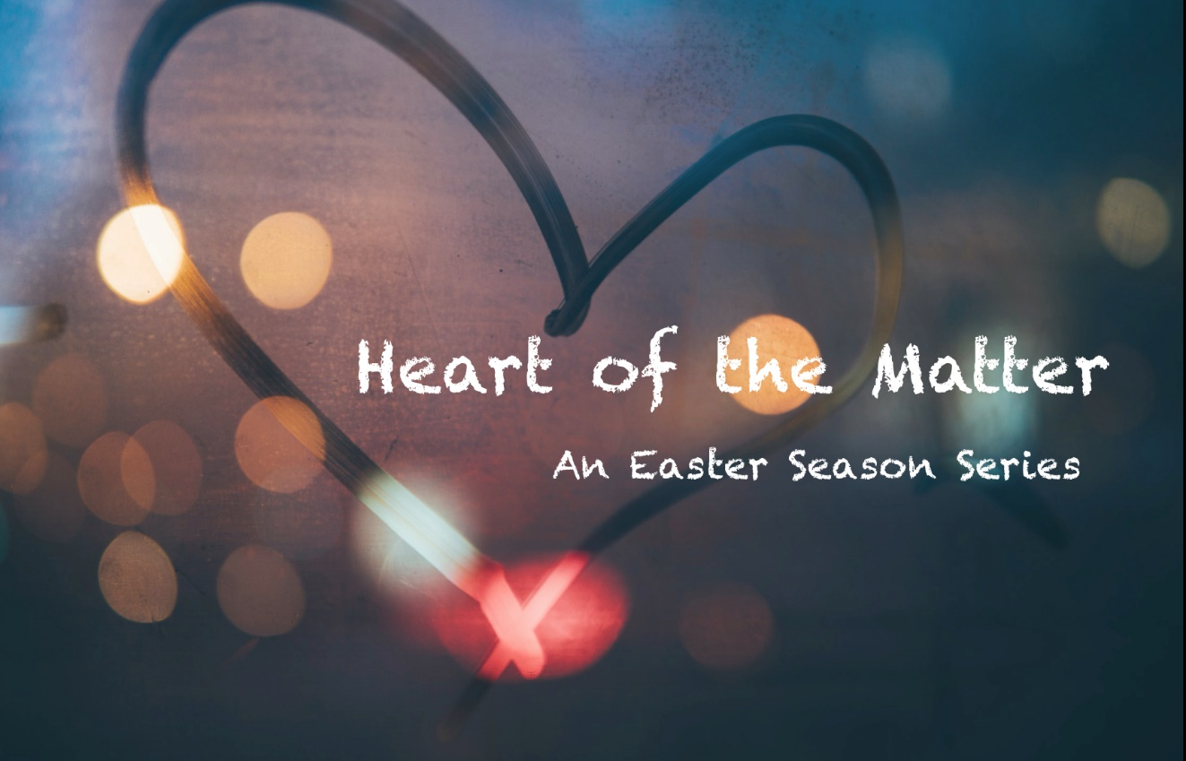

May 31, 2020 10:00 AM

PENTECOST sunday

PRELUDE "Come, Sound His Praise Above" Aaron Williams

WELCOME & ANNOUNCEMENTS

OPENING
The day of Pentecost has come! We have been spending time together each week being reminded that “love is our religion” and that our hearts have the Spirit of Christ within, helping us, guiding us, giving us strength and courage and overflowing gratitude for each other. All of this was inspired by the early Christian community, one that was often under difficult circumstances but continued to support each other along the way: “Day by day, as they spent much time together in the temple, they broke bread at home and ate their food with glad and generous hearts, praising God and having the goodwill of all the people.”(Acts 2: 46-47a) We create a “temple” of worship in our hearts that connects us across boundaries, distance and time. But as we share this worship, we will stay connected. At the “heart of the matter,” we are connected through the Spirit that makes us one in love.

OPENING ACT OF CENTERING OUR HEARTS AS ONE

HYMN “Gather Us In” FWS 2236

CALL TO PRAYER “Love the Lord Your God” FWS 2168

PRAYERS OF THE PEOPLE

THE LORD’S PRAYER
Our Father who art in heaven, hallowed be thy name, thy kingdom come, thy will be done on earth as it is in heaven. Give us this day our daily bread; and forgive us our trespasses as we forgive those who trespass against us. And lead us not into temptation, but deliver us from evil, for thine is the kingdom, and the power and the glory forever. Amen.

MUSIC MINISTRY "Holy Spirit, Living Breath of God" K. Getty and S. Townsend

GIVING OUR GIFTS – We can give online at our website:

www.umc-westwood.org

or we can mail our gifts in to the church office:

105 Fairview Ave. Westwood, NJ 07675

OFFERTORY PRAYER
Holy Spirit breathe into our lungs so that we may feel your peace with us. Holy Spirit breathe into the lives of those people who are touched by the ministries of this church so they, too, may feel your peace. Holy Spirit receive the outpouring of these generous gifts offered unto you. In the name of the One who first offered the gift of the Holy Spirit, we pray. Amen.

FIRST SCRIPTURE LESSON
Reader: We return to a scripture that describes a time, before Jesus’ crucifixion, when he had traveled to the temple in Jerusalem for the Jewish Festival of Booths. This was a very important time of celebrating the harvest and also remembering the Israelite’s journey out of Egypt and their dependence on God to provide sustenance. As our scripture says, Jesus pronounced that another Holy Sustainer would come–the Spirit that would flow from him, from God, and then from within us.
John 7:37-39

HYMN “God of Grace and God of Glory” UMH 577

SECOND LESSON
Reader: And so the Spirit did come after Jesus had left this earthly home. The Spirit, as in the previous reading is sometimes symbolized in flowing water and sometimes as wind and fire!
Acts 2:1-21

Reader: Throughout this season, we have proclaimed that love is that which binds us to God, to Jesus, to each other. Love IS our religion. On the day of Pentecost, the church received the power of the Holy Spirit to let this message flow out from all, to all. The power of this message is ever-so important to offer to the world today. The Spirit is poured out on each one of us so let us be a community of messengers letting living compassion flow from our hearts.

TODAY’S MESSAGE “The Heart of the Matter” Tim Chew

AFFIRMATION OF FAITH UMH 882

PRAISE GOD!

CLOSING HYMN “We Are the Church” UMH 558

BENEDICTION

POSTLUDE "Joyful Day" Mark Hayes

