WESTWOOD UNITED METHODIST CHURCH

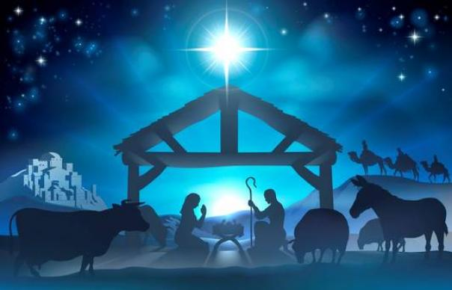

December 24, 2020 7:30 PM

CHRISTMAS EVE

PRELUDE "A Shepherd's Lullaby" Chas. Callahan

WELCOME

OPENING OURSELVES TO WORSHIP

LIGHTING THE ADVENT CANDLE
CAROL “O Come All Ye Faithful”

THE STORY OF CHRISTMAS

The Nativity
Carol: Away in a Manger (verses 1, 2)

The Holy Family (Luke 2: 1-7)
Carol: What Child is This? (verse 1)

The Angels (Luke 2: 8-14)
Carol: Hark! the Herald Angels Sing (verse 1)

The Shepherds (Luke 2: 15-20)
Carol: The First Noel (verse 1)

The Christmas Star (Matthew 2: 1 - 6)
Carol: The First Noel (verse 4)

The Wise Men (Matthew 2: 7 - 11)
Carol: We Three Kings (verse 1)

CAROL “Go Tell It On the Mountain”

GIVING OUR GIFTS
We can give online at our website: www.umc-westwood.org,
or we can mail our gifts into the church office:
105 Fairview Ave. Westwood, NJ 07675)
OFFERTORY PRAYER
We celebrate the birth of the Holy Child! Although born in humble surroundings, Jesus’ presence surrounds all who call upon his name. The hope born in a manger long ago is birthed again. We gratefully offer these financial gifts as a way to provide hope for all God’s children. We rejoice in knowing that your ministry is strengthened by our gifts and prayers. We pray in the name of the Babe in the Manger. Amen.

THE WITNESS OF MUSIC: “O Holy Night”
For all of Advent, we have called on the power of music that inspires those who hear it to a brighter tomorrow. It has been a difficult time in this pandemic for singing to be restricted. In its absence, we have been reminded just how important it is to sing together. Indeed, music has often been the soundtrack of hope. We enjoyed a season of music appreciation–as well as reflection on the power of music. We have also been presented with Carols of Resistance that have been sung as commentary on injustice. Tonight we bring you another. It is a song you will no doubt have heard on other Christmas Eve nights. But this time, listen with a new appreciation. Written in France by Placide Cappeau with melody by Adolphe Adams, the song was banned from church services when Cappeau’s theology was deemed heretical (some called him an atheist) and Adams’ music was labeled as “Jewish” (the ultimate insult in Christian circles at a time when Gregorian chant was having a resurgence). Further, the song’s message of humility and shared humanity went against the late 19th century idea that slaves did not have souls. Even though the church in France tried to kill the song, the American abolitionist and Unitarian minister, John Sullivan Dwight, made it popular in the Civil War era with its third verse proclaiming a radical message:

“Truly he taught us to love one another; his law is love and his gospel is peace. Chains shall he break, for the slave is our brother; and in his name all oppression shall cease.”

Someday, we will once again be able to join our full voices in song in our sanctuary. We will sing as never before. For now we allow this song to be a prayer of hope that we will destroy the inequity that still haunts us.

SONG “O Holy Night”

A CHRISTMAS COMMUNION
LORD’S PRAYER
Our Father who art in heaven, hallowed be thy name, thy kingdom come, thy will be done on earth as it is in heaven. Give us this day our daily bread; and forgive us our trespasses as we forgive those who trespass against us. And lead us not into temptation, but deliver us from evil, for thine is the kingdom, and the power and the glory forever. Amen.

INTRODUCTION TO “Silent Night”
CAROL “Silent Night”

BENEDICTION

POSTLUDE

